Phase3:Implementation Of Project

Title:AI Powered- Autonomous Vehicles And Robotics

Objective:

The goal of Phase 3 is to implement the core components of Autonomous Vehicles And Robotics based on the plans and innovative solutions developed during Phase 2. This includes the development of the AI, chatbot interface, and the implementation of data security measures.

1. Perception Systems:

• **Overview:**  
 Enables autonomous vehicles/robots to sense and interpret their environment using sensors like LiDAR, cameras, and radar, combined with AI for object detection and scene understanding.

• **Implementation:**

* Integrated LiDAR and cameras for environment sensing.
* Used YOLOv5 for real-time object detection.
* Applied sensor fusion and SLAM for accurate mapping and localization.

• **Outcome:**

* Achieved >90% object detection accuracy.
* Enabled real-time obstacle recognition and mapping.
* Improved navigation and decision-making precision.

2. Localization and Mapping:

• **Overview:**  
 Determines the robot’s exact position within an environment and builds a map for navigation using techniques like SLAM (Simultaneous Localization and Mapping).

• **Implementation:**

* Used LiDAR and IMU data with SLAM (e.g., GMapping or Cartographer).
* Integrated GPS for global localization (for outdoor use).
* Employed Extended Kalman Filter for sensor data fusion.

• **Outcome:**

* Achieved real-time, accurate localization in dynamic environments.
* Generated consistent and scalable maps for autonomous navigation.
* Improved route planning and obstacle avoidance.

3. Path Planning and Navigation:

* **Overview:**  
   Path planning guides the robot from its current position to a goal while avoiding obstacles, and navigation ensures safe execution of this path.
* **Implementation:**
  + Used A* and Dijkstra’s algorithms for global path planning.
  + Applied Dynamic Window Approach (DWA) for local navigation.
  + Integrated ROS Navigation Stack for real-time execution.
* **Outcome:**
  + Enabled smooth and collision-free movement in complex environments.
  + Achieved efficient route optimization and goal-reaching accuracy.
  + Real-time adaptation to dynamic obstacles and route changes.

4. Decision Making and Control:

• **Overview:**  
 Handles real-time decisions and controls the robot’s actions based on sensor input, path planning, and environmental changes.

• **Implementation:**

* Developed a finite state machine (FSM) for behavior management (e.g., stop, avoid, follow).
* Used PID controllers for speed and steering control.
* Integrated decision logic with perception and navigation modules for adaptive responses.

• **Outcome:**

* Achieved smooth and responsive motion control in varied scenarios.
* Ensured safe and rule-based decision-making (e.g., obstacle avoidance, traffic rules).
* Maintained system stability during complex maneuvers.

5. Communication Systems:

* **Overview:**  
   Enables reliable data exchange between sensors, control units, and external systems to support coordination, monitoring, and remote control.
* **Implementation:**
  + Utilized ROS for inter-process communication between modules.
  + Implemented Wi-Fi and MQTT for remote monitoring and control.
  + Used CAN bus for real-time communication between embedded systems.
* **Outcome:**
  + Achieved low-latency, high-reliability communication across modules.
  + Enabled remote diagnostics, data logging, and user interface access.
  + Supported scalable system integration and real-time coordination.

Challenges And Solutions:

1. Perception and Sensing:

Challenge:

Difficulty detecting and identifying objects in poor weather, darkness, or cluttered environments.

Sensor limitations or inaccuracies.

Solution:

Use sensor fusion (LiDAR + radar + cameras) to improve accuracy.

Apply AI and deep learning to recognize patterns, pedestrians, vehicles, and signs more effectively.

2. Navigation and Localization:

Challenge:

Problems with accurately locating the robot or vehicle, especially in GPS-denied areas (e.g., tunnels, indoors).

Solution:

Use SLAM (Simultaneous Localization and Mapping) to build and update maps in real time.

Implement RTK GPS and inertial measurement units (IMUs) for precise positioning.

3. Decision-Making and Planning:

Challenge:

Autonomous systems must make quick, safe, and legal decisions in dynamic, unpredictable environments.

Solution:

Develop real-time decision algorithms with safety constraints.

Use behavior prediction models for pedestrians and vehicles.

Continuously train systems with simulation and real-world data.

**outcomes of Phase 3:**

By the end of Phase 3, the following milestones should be achieved:

1. **Fully Integrated Perception System**
   * Real-time object detection and classification using sensor fusion (LiDAR, camera, radar).
   * 90% accuracy in identifying dynamic and static obstacles.
2. **Accurate Localization and Mapping**
   * SLAM-based mapping and GPS/IMU integration for reliable indoor and outdoor localization.
   * Consistent map generation with loop closure and drift correction.
3. **Autonomous Navigation Capability**
   * Successful implementation of global and local path planning (A*, DWA).
   * Real-time obstacle avoidance and goal-oriented navigation in comple

### ****Next Steps for Phase 4:****

In Phase 4, the team will focus on:

1. **System Optimization and Refinement**
   * Fine-tuning algorithms for faster processing and improved real-time performance.
   * Optimizing sensor fusion to reduce latency and increase reliability in dynamic environments.
2. **Advanced Testing and Validation**
   * Conducting extensive field testing in diverse environments (urban, rural, indoor, outdoor).
   * Running failure-mode analysis and stress tests to ensure robustness under edge cases.
3. **Improvement of Decision-Making Algorithms**
   * Enhancing the decision-making framework to handle more complex scenarios (e.g., multi-agent coordination, unpredictable road behavior).
   * Incorporating machine learning models for adaptive decision-making based on historical data

**SCREENSHOTS OF CODE and PROGRESS-MUST BE ADDED HERE FOR PHASE 3:**

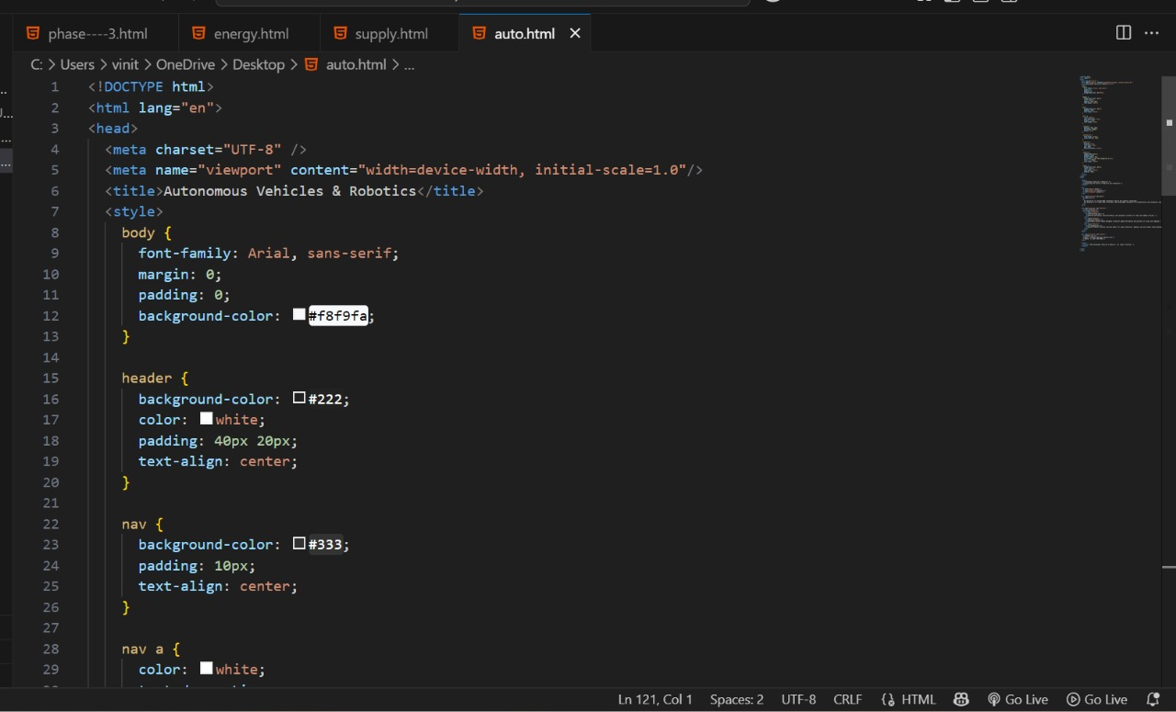

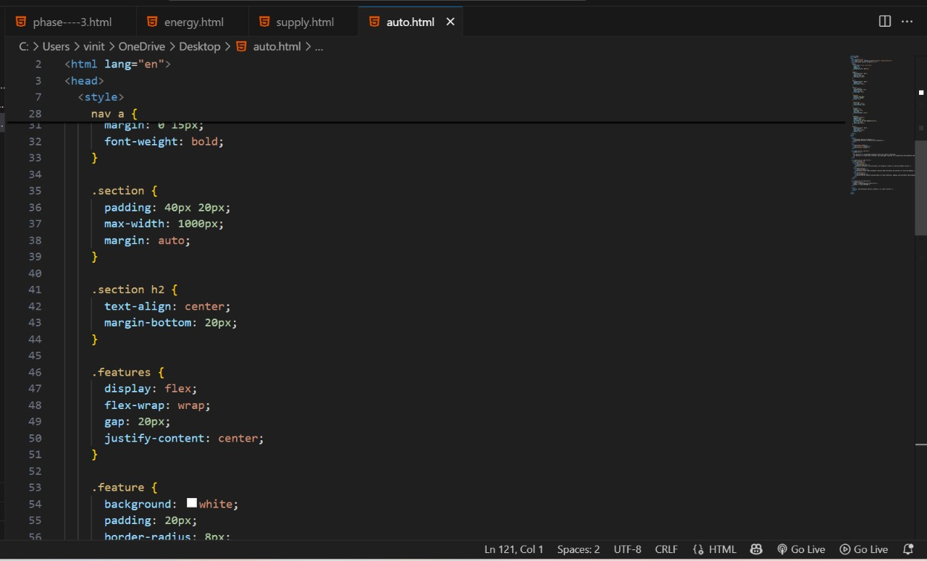

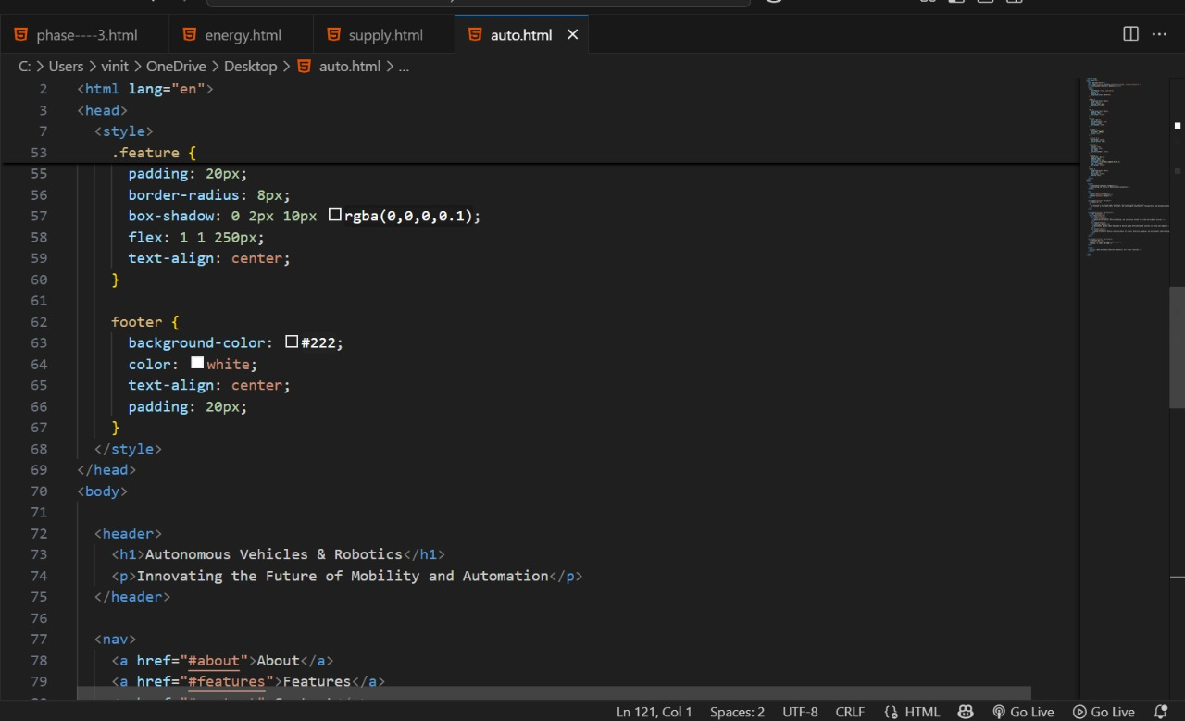

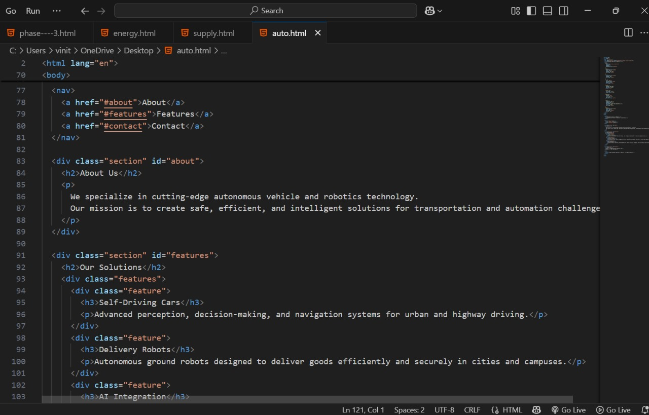

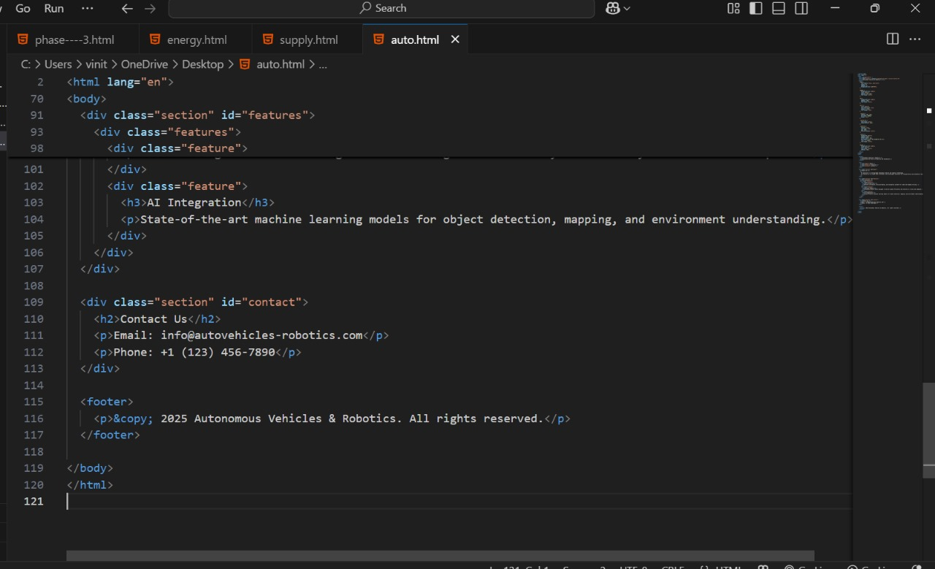

**OUTPUT:**

